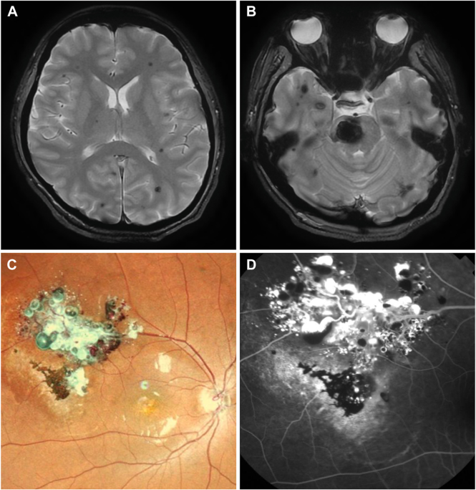

A 29-year-old woman presented with sudden onset of headache and paralysis of the left side. Magnetic resonance imaging showed as picture (A, B). Right fundus examination revealed grape-like hemorrhagic clusters (C), which had been observed in this patient since age 9. Fundus fluorescein angiography showed plasmaeerythrocyticseparation in some aneurysms (D). Cavernous malformations are congenital vascular anomalies found in the central nervous system or inthe retina. Based on the provided images and clinical description please make an ophthalmic diagnosis for this patient. And output the diagnostic conclusions only.

**Retinal cavernous malformation.**